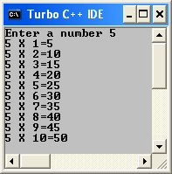
1) WAP to print tables of a number:
//ASS1/1 WAP to print tables of a given no
#include <iostream.h>
#include <conio.h>
main()
{
clrscr();
int a;
cout<<"Enter a number";
cin>>a;
cout<<a<<" X 1="<<a*1<<"\n";
cout<<a<<" X 2="<<a*2<<"\n";
cout<<a<<" X 3="<<a*3<<"\n";
cout<<a<<" X 4="<<a*4<<"\n";
cout<<a<<" X 5="<<a*5<<"\n";
cout<<a<<" X 6="<<a*6<<"\n";
cout<<a<<" X 7="<<a*7<<"\n";
cout<<a<<" X 8="<<a*8<<"\n";
cout<<a<<" X 9="<<a*9<<"\n";
cout<<a<<" X 10="<<a*10<<"\n";
getch();
}
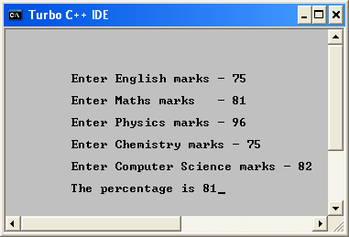
//ASS1/2 WAP that prints average percentage marks:-
#include <iostream.h>
#include <conio.h>
main()
{
clrscr();
int eng, mat, phy, chem, cs;
cout<<"\n\n\n\n\t Enter English marks - ";
cin>>eng;
cout<<"\n\t Enter Maths marks - ";
cin>>mat;
cout<<"\n\t Enter Physics marks - ";
cin>>phy;
cout<<"\n\t Enter Chemistry marks - ";
cin>>chem;
cout<<" \n\t Enter Computer Science marks - ";
cin>>cs;
int per;
per=(chem+phy+mat+cs+eng)/5;
cout<<"\n\t The percentage is "<<per;
getch();
}
3) WAP that prints cube:-
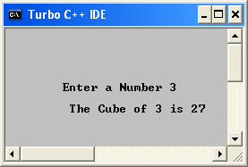
//ASS1/3 WAP that prints cube of a given number
#include <iostream.h>
#include <conio.h>
main()
{
clrscr();
int a, b;
cout<<" \n\n\n\n\n\tEnter a Number ";
cin>>a;
b=a*a*a;
cout<<"\n\t The Cube of "<<a<<" is "<<b;
getch();
}
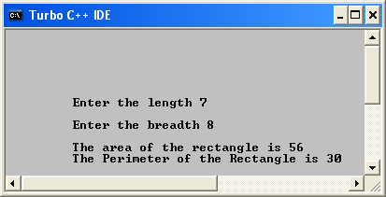
4)WAP that inputs radius and finds circumference and area of a circle:

//ASS1/4 WAP that prints circumference and area of a circle
#include <iostream.h>
#include <conio.h>
main()
{
clrscr();
float r, ar, pr;
cout<<" \n\n\n\n\n\t Enter the radius of the circle ";
cin>>r;
ar=3.14*r*r;
cout<<"\t The area is "<<ar;
pr=2*3.14*r;
cout<<"\n\t The Perimeter is "<<pr;
getch();
}

5)WAP to print Area and Perimeter of a Rectangle:
/* ASS 1/5WAP to print perimeter and Area of rectangle*/
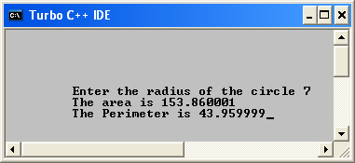
#include <iostream.h>
#include <conio.h>
main()
{
clrscr();
int len, brd, ar, pr;
cout<<"\n\n\n\n\n\n\t Enter the length ";
cin>>len;
cout<<"\n\t Enter the breadth ";
cin>>brd;
ar=len*brd;
cout<<"\n\t The area of the rectangle is "<<ar;
pr=2*(len+brd);
cout<<"\n\t The Perimeter of the Rectangle is "<<pr;
getch();
}
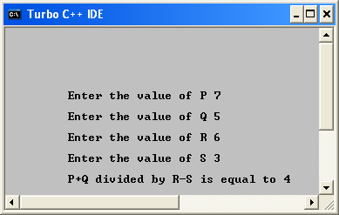
6)Integer z
//ASS1/6 To find value using P+Q/R-S
#include <iostream.h>
#include <conio.h>
main()
{
clrscr();
float p,q,r,s,z;
cout<<"\n\n\n\n\n\n\t Enter the value of P ";
cin>>p;
cout<<"\n\t Enter the value of Q ";
cin>>q;
cout<<"\n\t Enter the value of R ";
cin>>r;
cout<<"\n\t Enter the value of S ";
cin>>s;
z=(p+q)/(r-s);
cout<<"\n\t P+Q divided by R-S is equal to "<<z;
getch();
}

7) TEMPERATURE CALCULATION
//ASS 1/7WAP to change the unit of temperature
#include <iostream.h>
#include <conio.h>
main()
{
clrscr();
float c,f;
cout<<" \n\n\n\n\t Enter the temp. in Celsius ";
cin>>c;
f=c*(9.0/5.0)+32;
cout<<"\n\t The temperature in Farenheit is "<<f;
getch();
}

